UNIVERSITY OF WAH (UOW)

DEPARTMENT OF COMPUTER SCIENCE



COURSE TITLE: ARTIFICIAL INTELLIGENCE

COURSE CODE: CS – 202 L

SUBMITTED TO: SIR HASSAN SHAFAQAT

SUBMITTED BY: SAADI SAFDAR

REG #: UW-24-CS-BS-088

BSCS 3RD B

FINAL LAB SESSIONAL

Q1:
#Q1
#1
print("Zulqarnain Malik")
print("Muhammad Ashraf")
print("19-08-2004")
#2
original_string = "Python"
reversed_string = original_string[::-1]
print("Original:", original_string)
print("Reversed:", reversed_string)
my_string = "Hello World"
#3
my_string = "Hello World"
count = len(my_string)
print("String:", my_string)
print("Number of characters:", count)
#4
university = "University OF Wah"
campus = "Quaid Campus"
semester = "3nd Semester"
reg_number = "uw-24-cs-bs-043"
print("University Name:", university)
print("Campus:", campus)
print("Class/Semester:", semester)
print("Registration No:", reg_number)
#5
a = 5
b = 10
print(f"Before swapping: a = {a}, b = {b}")
a, b = b, a
print(f"After swapping: a = {a}, b = {b}")

OUTPUT:

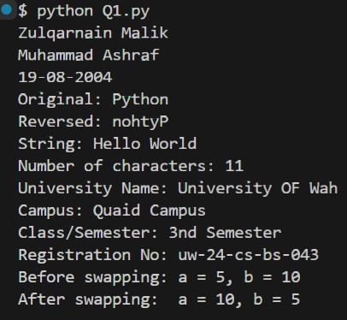

Q2:
graph = {
'A': ['B', 'D', 'C'],
'B': ['A', 'E'],
'C': ['A', 'F'],
'D': ['A', 'C', 'E', 'G'],
'E': ['B', 'D', 'G'],
'F': ['C', 'G'],
'G': ['E', 'D', 'F']
}
def bfs(start_node):
visited = set()
queue = deque([start_node])
print("BFS Traversal:")
while queue:
current = queue.popleft()
if current not in visited:
print(current, end=' ')
visited.add(current)
for neighbor in graph[current]:
if neighbor not in visited:
queue.append(neighbor)
bfs('A')

OUTPUT:

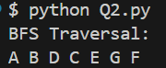

Q3:
import heapq
def a_star_search(graph, heuristics, start, goal):
open_list = []
initial_f = 0 + heuristics[start]
heapq.heappush(open_list, (initial_f, start, [start], 0))
visited_costs = {start: 0}
while open_list:
f, current, path, g = heapq.heappop(open_list)
if current == goal:
return path, g
for neighbor, weight in graph.get(current, {}).items():
new_g = g + weight
if neighbor not in visited_costs or new_g < visited_costs[neighbor]:
visited_costs[neighbor] = new_g
new_h = heuristics.get(neighbor, 0)
new_f = new_g + new_h
new_path = path + [neighbor]
heapq.heappush(open_list, (new_f, neighbor, new_path, new_g))
return None, float('inf')
cities_graph = {
'Islamabad': {'Peshawar': 174, 'Lahore': 260, 'Quetta': 714, 'Faisalabad': 388},
'Peshawar': {'Sialkot': 260, 'Lahore': 385},
'Sialkot': {'Lahore': 238},
'Lahore': {'Multan': 338, 'Karachi': 437},
'Faisalabad':{'Multan': 161},
'Quetta': {'Multan': 388, 'Faisalabad': 161},
'Multan': {'Sukkur': 313},
'Sukkur': {'Karachi': 200}
}
heuristics = {
'Islamabad': 125,
'Peshawar': 695,
'Sialkot': 273,
'Lahore': 241,
'Faisalabad': 218,
'Quetta': 714,
'Multan': 357,
'Sukkur': 386,
'Karachi': 150
}
start_city = 'Islamabad'
destination_city = 'Karachi'
optimal_path, total_cost = a_star_search(cities_graph, heuristics, start_city, destination_city)
print(f"Optimal Route from {start_city} to {destination_city}:")
print(" -> ".join(optimal_path))
print(f"Total Travel Cost: {total_cost}")

OUTPUT:

